Phase 3: Document 1

American Dream - American Creed

Written by Culture, Burke High School
State: Nebraska
Original published to the Writing Our Future: American Creed website (2018)

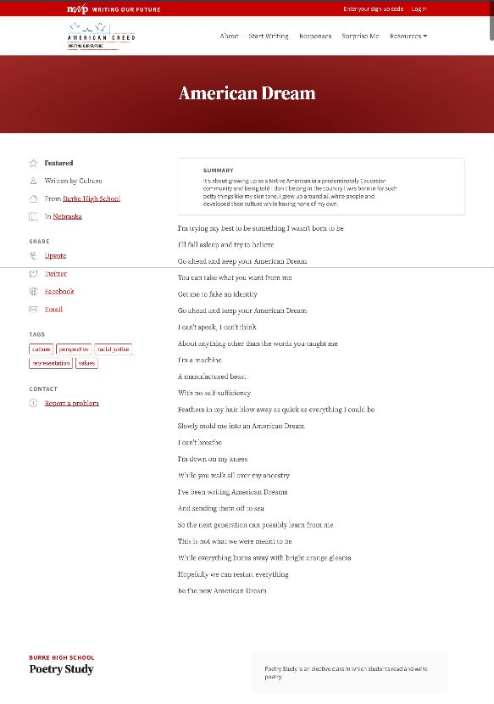
2018 screenshot of this post

Summary: It's about growing up as a Native American in a predominately Caucasian community and being told I don't belong in the country I was born in for such petty things like my skin tone. I grew up around all white people and developed their culture while having none of my own.

I’m trying my best to be something I wasn’t born to be

I’ll fall asleep and try to believe

Go ahead and keep your American Dream

You can take what you want from me

Get me to fake an identity

Go ahead and keep your American Dream

I can’t speak, I can’t think

About anything other than the words you taught me

I’m a machine

A manufactured beast

With no self-sufficiency

Feathers in my hair blow away as quick as everything I could be

Slowly mold me into an American Dream

I can’t breathe

I’m down on my knees

While you walk all over my ancestry

I’ve been writing American Dreams

And sending them off to sea

So the next generation can possibly learn from me

This is not what we were meant to be

While everything burns away with bright orange gleams

Hopefully we can restart everything

Be the new American Dream

Phase 3: Document 2
My Family and the American Creed
Written by Solo L., Emerald Coast National Writing Project
State: Florida
Original published to the Writing Our Future: American Creed website (2018)

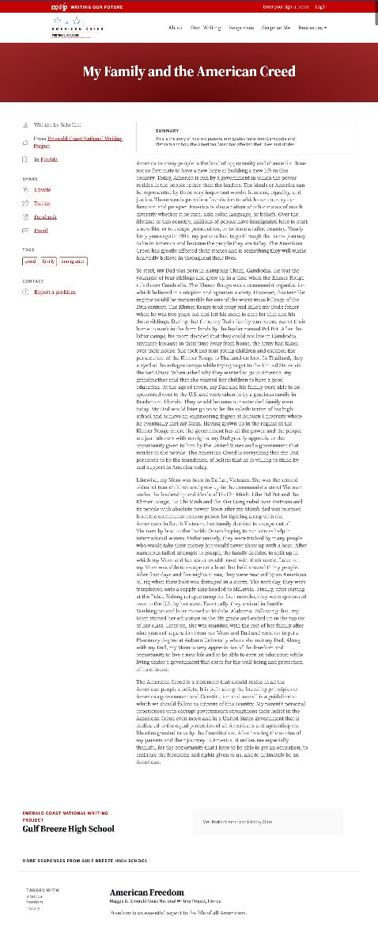
2018 screenshot of this post

Summary: This is the story of how my parents immigrated here from Cambodia and Vietnam and how the American Creed has affected their lives and stories.

America to many people is the land of opportunity and chance for those not so fortunate to have a new hope at building a new life in this country. Today, America is run by a government in which the power resides in the people rather than the leaders. The ideals of America can be represented by three very important words: freedom, equality, and justice. These words provide a foundation to which our country can function and prosper. America is also a nation which consists of much diversity whether it be race, skin color, language, or beliefs. Over the lifetime of this country, millions of people have immigrated here to start a new life, or to escape persecution, or to leave a failed country. Nearly forty years ago in 1981, my parents had to go through that same journey to be in America and become the people they are today. The American Creed has greatly affected their stories and is something they will whole heartedly believe in throughout their lives.

To start, my Dad was born in Kampong Cham, Cambodia. He was the youngest of four siblings and grew up in a time when the Khmer Rouge ruled over Cambodia. The Khmer Rouge was a communist organization which believed in a utopian and agrarian society. However, this terrible regime would be responsible for one of the worst mass killings of the 20th century. The Khmer Rouge took away and killed my Dad's father when he was two years old and left his mom to care for him and his three siblings. During that time, my Dad's family was forced out of their home to work in the farm lands by the leader named Pol Pot. After the labor camps, his mom decided that they could not live in Cambodia anymore because in their time away from home, the army had taken over their house. She took her four young children and escaped the persecution of the Khmer Rouge to Thailand on foot. In Thailand, they stayed at the refugee camps while trying to get to the United States via the Red Cross. When asked why they wanted to go to America, my grandmother said that she wanted her children to have a good education. At the age of seven, my Dad and his family were able to be sponsored over to the U.S. and were taken in by a gracious family in Bradenton, Florida. They would become our extended family even today. My Dad would later go on to be the valedictorian of his high school and achieve an engineering degree at Auburn University where he eventually met my Mom. Having grown up in the regime of the Khmer Rouge where the government has all the power and the people are just laborers with no rights, my Dad greatly appreciates the opportunity given to him by the United States and a government that resides in the people. The American Creed is everything that my Dad perceives to be the foundation of beliefs that he is willing to stand by and support in America today.

Likewise, my Mom was born in Da Lat, Vietnam. She was the second oldest of four children and grew up in the communist state of Vietnam under the leadership and ideals of Ho Chi Minh. Like Pol Pot and the Khmer Rouge, Ho Chi Minh and the Viet Cong ruled over Vietnam and its people with absolute power. Soon after my Mom's dad was released from the communist reform prison for fighting along with the Americans in South Vietnam, her family decided to escape out of Vietnam by boat to the Pacific Ocean hoping to run across help in international waters. Unfortunately, they were tricked by many people who would take their money but would never show up with a boat. After numerous failed attempts to escape, the family decided to split up in which my Mom and her sister would travel with their uncle. Later on, my Mom was able to escape on a boat that held around thirty people. After four days and five nights at sea, they were rescued by an American oil rig when their boat was damaged in a storm. The next day, they were transferred onto a supply ship headed to Malaysia. Finally, after staying at the Pulau Bidong refugee camp for four months, they were sponsored over to the U.S. by her aunt.
Eventually, they arrived in Seattle, Washington and later moved to Mobile, Alabama. Following that, my Mom started her education in the 7th grade and ended up in the top six of her class. Later on, she was reunited with the rest of her family after nine years of separation from her Mom and Dad and went on to get a Pharmacy degree at Auburn University where she met my Dad. Along with my Dad, my Mom is very appreciative of the freedom and opportunity to live a new life and to be able to earn an education while living under a government that cares for the well-being and protection of its citizens.

The American Creed is a statement that should reside in all the American people's beliefs. It is built along the founding principles of America's government and Constitution and overall is a guideline to which we should follow as citizens of this country. My parent's personal experiences with corrupt governments strengthens their belief in the American Creed even more and in a United States government that is dedicated to the equal protection of all Americans and upholding the liberties granted to us by the Constitution. After hearing the stories of my parents and their journey to America, it makes me especially thankful for the opportunity that I have to be able to get an education, to embrace the freedoms and rights given to us, and to ultimately be an American.

Phase 3: Document 3

The American Creed: What is Your Idea of the American Creed? - American Creed

By Kellen M., from Emerald Coast National Writing Project
State: Florida
Original published to the Writing Our Future: American Creed website (2018)

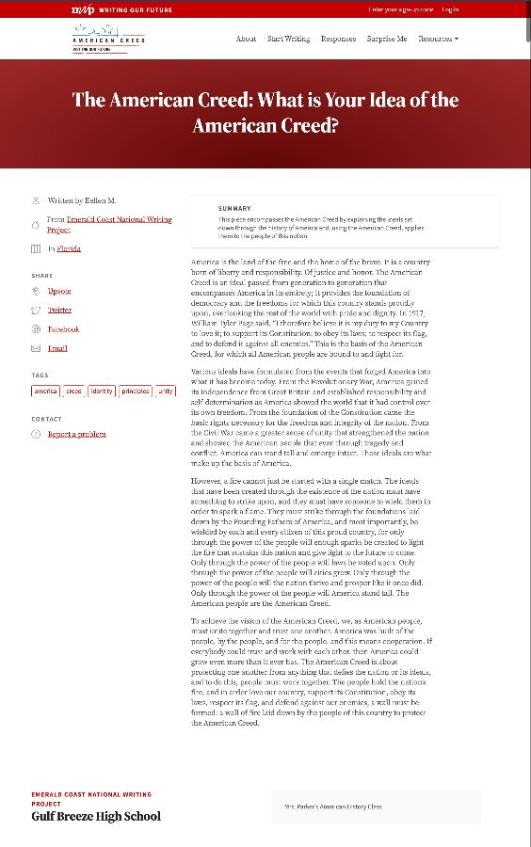
2018 screenshot of this post

Summary: This piece encompasses the American Creed by explaining the ideals set down through the history of America and, using the American Creed, applies them to the people of this nation.

America is the land of the free and the home of the brave. It is a country born of liberty and responsibility. Of justice and honor. The American Creed is an ideal passed from generation to generation that encompasses America in its entirety; it provides the foundation of democracy and the freedoms for which this country stands proudly upon, overlooking the rest of the world with pride and dignity. In 1917, William Tyler Page said, “I therefore believe it is my duty to my Country to love it; to support its Constitution; to obey its laws; to respect its flag, and to defend it against all enemies.” This is the basis of the American Creed, for which all American people are bound to and fight for.

Various ideals have formulated from the events that forged America into what it has become today. From the Revolutionary War, America gained its independence from Great Britain and established responsibility and self-determination as America showed the world that it had control over its own freedom. From the foundation of the Constitution came the basic rights necessary for the freedom and integrity of the nation. From the Civil War came a greater sense of unity that strengthened the nation and showed the American people that even through tragedy and conflict, America can stand tall and emerge intact. These ideals are what make up the basis of America.

However, a fire cannot just be started with a single match. The ideals that have been created through the existence of the nation must have something to strike upon, and they must have someone to wield them in order to spark a flame. They must strike through the foundations laid down by the Founding Fathers of America, and most importantly, be wielded by each and every citizen of this proud country, for only through the power of the people will enough sparks be created to light the fire that sustains this nation and give light to the future to come. Only through the power of the people will laws be voted upon. Only through the power of the people will cities grow. Only through the power of the people will the nation thrive and prosper like it once did. Only through the power of the people will America stand tall. The American people are the American Creed.

To achieve the vision of the American Creed, we, as American people, must unite together and trust one another. America was built of the people, by the people, and for the people, and this means cooperation. If everybody could trust and work with each other, then America could grow even more than it ever has. The American Creed is about protecting one another from anything that defies the nation or its ideals, and to do this, people must work together. The people hold the nation’s fire, and in order love our country, support its Constitution, obey its laws, respect its flag, and defend against our enemies, a wall must be formed: a wall of fire laid down by the people of this country to protect the American Creed.

Phase 3: Document 4

American Creed - American Creed

By Uluwehi B., Columbus High School in 2018
State: Montana
Original published to the Writing Our Future: American Creed website (2018)

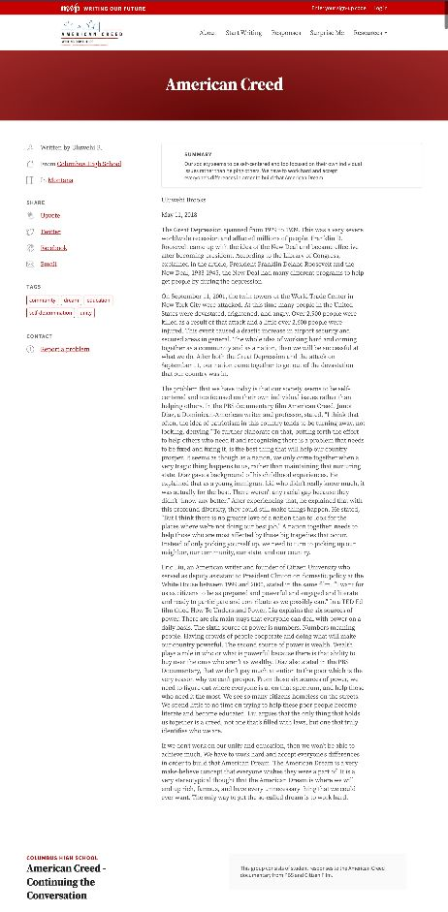
2018 screenshot of this post

Summary: Our society seems to be self-centered and too focused on their own individual issues rather than helping others. We have to work hard and accept everyone’s differences in order to build that American Dream.

The Great Depression spanned from 1929 to 1939. This was a very severe worldwide recession and affected millions of people. Franklin D. Roosevelt came up with the idea of the New Deal and became effective after becoming president. According to the Library of Congress, explained in the article, President Franklin Delano Roosevelt and the New Deal, 1933-1945, the New Deal had many different programs to help get people by during the depression.
On September 11, 2001, the twin towers of the World Trade Center in New York City were attacked. At this time many people in the United States were devastated, frightened, and angry. Over 2,900 people were killed as a result of that attack and a little over 2,600 people were injured. This event caused a drastic increase in airport security and secured areas in general. The whole idea of working hard and coming together as a community and as a nation, then we will be successful at what we do. After both the Great Depression and the attack on September 11, our nation came together to get out of the devastation that our country was in.

The problem that we have today is that our society seems to be self-centered and too focused on their own individual issues rather than helping others. In the PBS documentary film American Creed, Junot Diaz, a Dominican-American writer and professor, stated, “I think that often, the idea of patriotism in this country tends to be turning away, not looking, denying.” To further elaborate on that, putting forth the effort to help others who need it and recognizing there is a problem that needs to be fixed and fixing it, is the best thing that will help our country prosper. It seems as though as a nation, we only come together when a very tragic thing happens to us, rather than maintaining that nurturing state. Diaz gave a background of his childhood experiences. He explained that as a young immigrant kid who didn’t really know much, it was actually for the best. There weren’t any racial gap because they didn’t “know any better.” After experiencing that, he explained that with this profound diversity, they could still make things happen. He stated, “But I think there is no greater love of a nation than to look for the places where we’re not doing our best job.” A nation together, needs to help those who are most affected by those big tragedies that occur. Instead of only picking yourself up, we need to turn to picking up our neighbor, our community, our state, and our country.

Eric Liu, an American writer and founder of Citizen University who served as deputy assistant to President Clinton on domestic policy at the White House between 1999 and 2000, stated in the same film, “I want for us as citizens to be as prepared and powerful and engaged and literate and ready to participate and contribute as we possibly can.” In a TED Ed film titled How To Understand Power, Liu explains the six sources of power. There are six main ways that everyone can deal with power on a daily basis. The sixth source of power is numbers. Numbers meaning people. Having crowds of people cooperate and doing what will make our country powerful. The second source of power is wealth. Wealth plays a role in who or what is powerful because there is that ability to buy over the ones who aren’t as wealthy. Diaz also stated in the PBS Documentary, that we don’t pay much attention to the poor which is the very reason why we can’t prosper. From those six sources of power, we need to figure out where everyone is at on that spectrum, and help those who need it the most. We see so many citizens homeless on the streets. We spend little to no time on trying to help these poor people become literate and become educated. Liu argues that the only thing that holds us together is a creed, not one that’s filled with laws, but one that truly identifies who we are.

If we don’t work on our unity and education, then we won’t be able to achieve much. We have to work hard and accept everyone’s differences in order to build that American Dream. The American Dream is a very make-believe concept that everyone wishes they were a part of. It is a very stereotypical thought that the American Dream is where we will end up rich, famous, and have every unnecessary thing that we could ever want. The only way to get the so-called dream is to work hard.

