Phase 2: Document 1

SERIALSET-08579_00_00-152-0416-0000.pdf

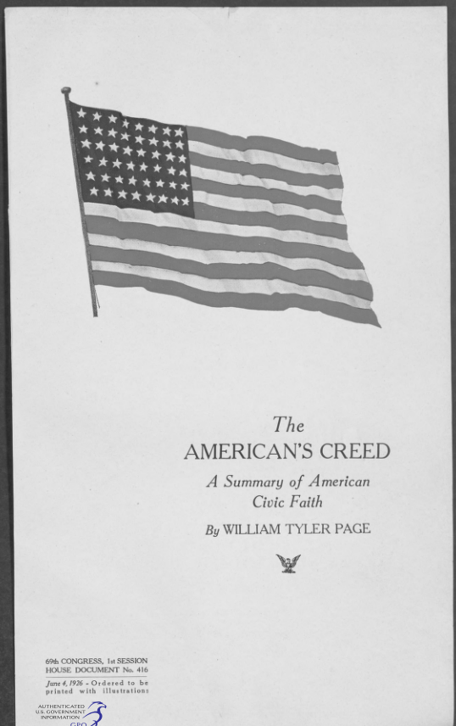

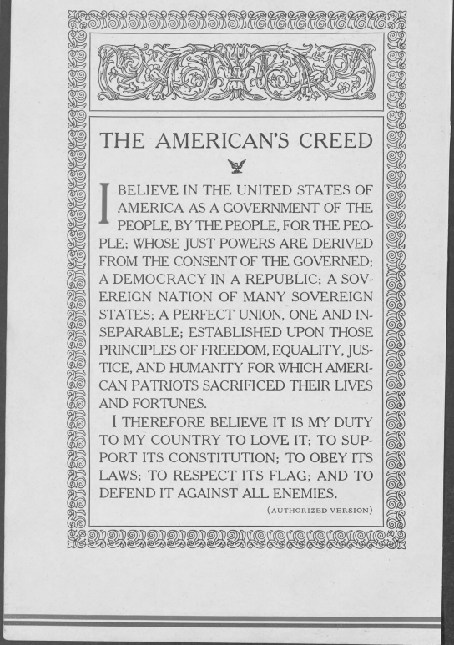

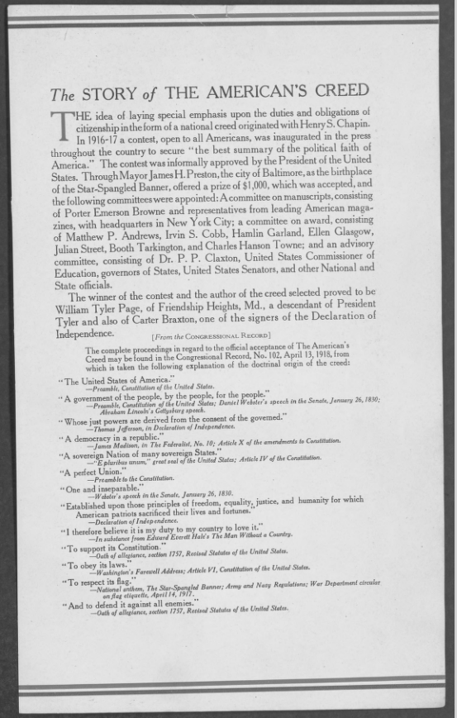
Phase 2: Document 2

George W. Bush: Bigotry and white supremacy are 'blasphemy' against the American creed.

Byline: Maegan Vazquez, CNN
WASHINGTON (CNN) -- Former President George W. Bush condemned bigotry and white supremacy Thursday while endorsing policies that run counter to those supported by President Donald Trump.
"Our identity as a nation, unlike other nations, is not determined by geography or ethnicity, by soil or blood. ... This means that people from every race, religion, ethnicity can be full and equally American," he said during remarks at the George W. Bush Institute in New York City. "It means that bigotry and white supremacy, in any form, is blasphemy against the American creed."
He added that "bigotry seems emboldened," though he didn't explain why.
"We've seen our discourse degraded by casual cruelty," Bush said, adding, "Too often, we judge other groups by their worst examples while judging ourselves by our best intentions, forgetting the image of God we should see in each other."
Bush didn't mention Trump during his remarks but did criticize the "governing class." In his recommendations to strengthen American democracy, he said US institutions must "step up" and "we need to recall and recover our own identity."
The speech marks a rare political appearance for Bush since leaving office. The former president has remained mostly out of the spotlight since he left the White House, reserving his political capital for his charitable works and a handful of his brother Jeb Bush's 2016 presidential campaign stops.
He brought up growing concerns over misinformation, saying politics seems "more vulnerable to conspiracy theories and outright fabrication."
The 43rd president, who left the presidential section of his ballot blank instead of voting for Trump, also addressed Russian influence on the United States.
"The Russian government has made a project of turning Americans against each other," he said, adding that while Russian interference will not be successful, "foreign aggressions, including cyberattacks, disinformation and financial influence, should never be downplayed or tolerated."
Bush, who entered into several free trade agreements during his tenure in the White House, referred to a trend towards protectionism, an apparent allusion to some of Trump's trade actions, which have included his decision to withdraw from the Trans-Pacific Partnership early this year and his warning that he's considering "stopping all trade with any country doing business with North Korea."
Bush also praised the positive contributions of immigrants -- a statement seemingly aimed at the Trump administration's hardline stances on immigration and border security.
"We've seen nationalism distorted into nativism -- forgotten the dynamism that immigration has always brought to America," Bush said. "We see a fading confidence in the value of free markets and international trade -- forgetting that conflict, instability, and poverty follow in the wake of protectionism."
The former president also addressed concerns over bullying among American leaders.
"Bullying and prejudice in our public life sets a national tone, provides permission for cruelty and bigotry, and compromises the moral education of children, the only way to pass along civic values is to first live up to them," he said.
Copyright: COPYRIGHT 2017 CNN Newsource Sales, Inc.
https://www.cnn.com/

Phase 2: Document 3

American Creed: Philanthropy and the Rise of Civil Society, 1700-1865.

American Creed: Philanthropy and the Rise of Civil Society, 1700-1865. By Kathleen D. McCarthy. (Chicago and London: University of Chicago Press, 2003. Pp. xii, 319. $35.00.)
Thomas Jefferson formulated the "American Creed" in the Declaration of Independence, and in identifying his four most significant accomplishments, Kathleen D. McCarthy asserts in this new study that Jefferson's American creed is "faith in egalitarian ideals, religious freedom, and the right to engage in civic activism" (1). Over the course of the 165 years that this book covers, putting the creed into practice in philanthropy--building a civil society--is a task that the author recounts with spirit and sympathy. The constant activism of philanthropic citizens, particularly women, to which the author devotes the most attention and for which she provides the fullest analysis, was mainly responsible for success. The market economy in the North provided aid; state governments were of limited help, and the federal government assisted the least.
Benjamin Franklin is the author's principal example of a colonial-era philanthropist. His efforts to gain government support and his wisely invested bequest, establishing loans to deserving mechanics, were models for many later philanthropic efforts. Anthony Benezet, who undertook aiding victims of war, Native Americans, and African Americans, deserves much more attention than McCarthy gives him, however.
Although detailing women's actions, the utilization of the developing market economy, and attempts to obtain government support, McCarthy discusses the major philanthropic endeavors before 1877. Missionary work, many charitable efforts, establishing educational institutions, abolition, protecting Native American rights, reform of treatment of the insane, and aid for soldiers and former slaves during and after the Civil War are her major examples. She also gives attention to Catholic and Jewish women who were involved in philanthropy.
McCarthy's account of the partnership of private investment and philanthropy notes that businessmen oversaw the investment of philanthropic endowments in growing northeastern industries and transportation facilities. This helped to spur the economy and produce returns that were then utilized for further philanthropic efforts. She implies, but does not provide evidence to demonstrate, that private philanthropy opposed government-funded philanthropy and intentionally "underwrote the nation's commitment to limited government" by serving social needs with private philanthropic donations (206). Conversely, the author shows that cooperation of government and private philanthropy was important during Reconstruction.
Politicians limited federal philanthropy. McCarthy effectively discusses Jackson's failings as a philanthropist, his catering to popular white racism, and his supporters' use of philanthropic institutions to finance state and city spoils systems. She neglects to censure sufficiently Franklin Pierce for "politics as usual" in his veto of the Asylum Bill of 1854. Pierce's Democratic senatorial allies saw it as a Free Soil bill, adverse to their policy of limiting federal authority so that slavery might expand.
McCarthy's praise for James Madison's "authorizing the use of federal funds for missionary societies" and other groups and for states that gave specific aid and textbooks, per child, to the American Sunday School Union, which was teaching religion, seems to contradict her strong advocacy of Jeffersonian views of separation of church and state.
Texas Tech University
Benjamin H. Newcomb
Copyright: COPYRIGHT 2004 Phi Alpha Theta, History Honor Society, Inc.

Phase 2: Document 4

United States Creed: The American's Creed

United States Creed

"The American's Creed"
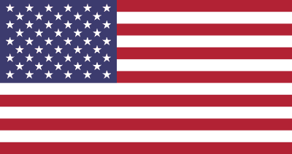

Written by William Tyler Page of Friendship Heights

Adopted on April 3, 1918.
The American's Creed is a the title of a resolution passed by the U.S. House of Representatives April 3, 1918. It is a statement written in 1917 by William Tyler Page as an entry into a patriotic contest.

"The American's Creed"

The American's Creed
I BELIEVE IN THE UNITED STATES OF AMERICA AS A¹ GOVERNMENT OF THE PEOPLE, BY THE PEOPLE, FOR THE PEOPLE;² WHOSE JUST POWERS ARE DERIVED FROM THE CONSENT OF THE GOVERNED;³ A DEMOCRACY IN A REPUBLIC,⁴ A SOVEREIGN NATION OF MANY SOVEREIGN STATES;⁵ A PERFECT UNION, ONE AND INSEPARABLE;⁶ ESTABLISHED UPON THOSE PRINCIPLES OF FREEDOM, EQUALITY, JUSTICE, AND HUMANITY FOR WHICH AMERICAN PATRIOTS SACRIFICED THEIR LIVES AND FORTUNES.⁷
I THEREFORE BELIEVE IT IS MY DUTY TO MY COUNTRY TO LOVE IT,⁸ TO SUPPORT ITS CONSTITUTION;⁹ TO OBEY ITS LAWS;¹⁰ TO RESPECT ITS FLAG; AND¹¹ TO DEFEND IT AGAINST ALL ENEMIES.¹²
Key to the The American's Creed:, 1. Closing words of Preamble to the Constitution; 2. Lincoln's Gettysburg Address; 3. Declaration of Independence; 4. James Madison in The Federalist, No. X; 5. Speech by Daniel Webster, Jan. 26, 1830; 6. Preamble to the Constitution; 7. Adapted from closing words of Declaration of Independence; 8. Speech by John Hancock; 9. United States Oath of Allegiance; 10. George Washington's Farewell Address; 11. War Department Circular, April 14, 1917; 12. Oath of Allegiance.

History
The American's Creed was a result of a nationwide contest for writing a National Creed, which would be a brief summary of the American political faith founded upon things fundamental in American history and tradition. The contest was the idea of Henry Sterling Chapin, Commissioner of Education of New York State. Over three thousand entries were received, and William Tyler Page was declared to be the winner. James H. Preston, the mayor of Baltimore, presented an award to Page in the House of Representatives Office Building on April 3, 1918. The Speaker of the House of Representatives and the commissioner of education of the state of New York accepted the Creed for the United States, and the proceedings relating to the award were printed in the Congressional Record of April 13, 1918. It was a time when patriotic sentiments were very much in vogue. The United States had been a participant in World War I only a little over a year at the time the Creed was adopted.
The author of the American's Creed, William Tyler Page, was a descendant of John Page, who had come to America in 1650 and had settled in Williamsburg, Virginia, and who served in the Congress from 1789-97. Another ancestor, Carter Braxton, had signed the Declaration of Independence. Still another ancestor, John Tyler, was the tenth president of the United States. William Tyler Page had come to Washington at the age of thirteen to serve as a Capitol Page. William Tyler Page began his government career as a Congressional page in December of 1881. Later he became an employee of the Capitol building and served in that capacity for almost sixty-one years. In 1919 he was elected clerk of the House. Thirteen years later, when the Democrats again became a majority party, they created for Page the office of minority clerk of the House of Representatives. He held this position for the remainder of his life until his death on October 20, 1942..
Referring to the Creed, Page said: "It is the summary of the fundamental principles of the American political faith as set forth in its greatest documents, its worthiest traditions, and its greatest leaders." His wording of the Creed used passages and phrases from the Declaration of Independence, the Preamble to the Constitution, Lincoln's Gettysburg Address, and Daniel Webster's reply to Robert Y. Hayne in the Senate in 1830.

