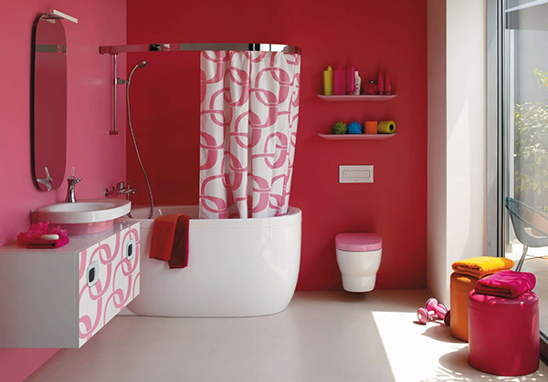
Home Audit Worksheet
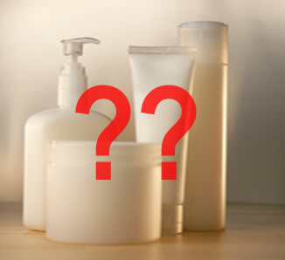


SITE TOXINS Type of Product Safer Alternative Red Flag Ingredients

BATHROOM

BEDROOM

List of Red Flag Words To Look For:

Phthalates
    - Endocrine disruptors prevent hormones from functioning normally
    - Have been found to produce cancer of the liver and birth defects in lab animals
    - Phthalates “hide” behind the term “fragrance”
    - Companies are not required to reveal the ingredients making up fragrance mixtures on the labels of products.

Sodium Lauryl Sulfate and Sodium Laureth Sulfate
      - Has been found to cause “severe epidermal changes” to mouse skin

Toluene
      - Can cause liver damage and is irritating to the skin and respiratory tract

Diethanolamine (DEA)
      - A suspected carcinogen & even more hazardous if the product also contains bronopol, a bactericicde

Parabens
      - Found in Breast Cancer Tissue
      - Endocrine disrupting compounds

Glycol ethers
      - Found in nail polish, deodorant, perfumes and other cosmetics
      - Effects include skin, eye, nose and throat irritations

Triclosan
      - A pesticide that is suspected of harming the natural environment and aquatic creatures
      - Found in antibacterial soap

